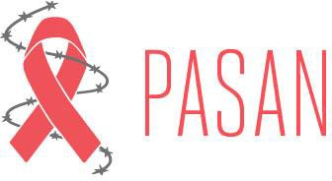

CALL FOR BOARD MEMBERS

PASAN is looking for people to join our board of directors who are passionate about prison justice, harm reduction and HIV/Hep C health promotion.

We are looking for people with lived experience and/or familiarity with prison systems, HIV or Hep C. and who have skills/experience in any of the following areas:
- Accounting
- Non-profit governance
- Fundraising
- Communications
- Advocacy

As a member of our board, you’ll meet and collaborate with a dedicated group of individuals committed to prisoners’ justice and advocating for prisoner/ex- prisoner equitable access to HIV, Hep C and harm reduction resources.

By attending monthly board meetings and serving on one or more board committees, you will have the opportunity to contribute to PASAN’s strategic direction and support the organization in communicating and achieving its mandate, particularly regarding Advocacy, Board Development, Decolonization, Anti-Oppression/Anti-Racism, Finance, and Fundraising.

PASAN is committed to building an organization that reflects the communities we serve. We strongly encourage applications from equity seeking communities including people from Indigenous. African/Caribbean/Black and racialized communities, people who use drugs ex-prisoners, people living with HIV/Hep C, Two Spirit, LGBTQ people and members of other equity seeking groups

For more information, please e-mail Board Development Committee at info@pasan.org

www.pasan.org
526 Richmond Street East, Toronto, ON, M5A1R3
PH:416-920-9567  Toll Free 1-866-224-9978

