Briefing Note To Mid-West Toronto OHT Partner table
Information | DIscussion | Approval

Issue: Background and Intended use of the “don’t neglect your health” memo

May 25, 2020

Background
- Members of the Mid-West Toronto Ontario Health Team (MWT-OHT) Executive Project Advisory Committee (EPAC) raised concerns about their patient/client population putting off urgent or chronic maintenance healthcare services since the start of COVID-19 pandemic due to fear of entering public space.
- The new practice of health care avoidance due to fears of COVID-19 transmission poses a threat to (1) the immediate well-being of our patients, and (2) our health care system in the form of a ‘second wave’ of demand from delayed visits.
- Fearing this ‘second wave’ of healthcare demand from delayed or neglected care, EPAC recommended that a letter be drafted and sent to residents of Mid-West Toronto to demystify the risks of care visits and to advocate for patients to not neglect their health.
Memo Distribution
- The attached memo is intended to be used by any and all of our OHT partners;
- Please distribute the attached memo to whomever you like and through whichever channels you like;
- Prior to distribution, please update the memo to include contact information for someone within your office or organization who can field questions/concerns and assist in navigation;
- The memo is intentionally not branded as the MWT-OHT is still in its development phase

Attached: MWT-OHT Memo - Don't Neglect Your Health

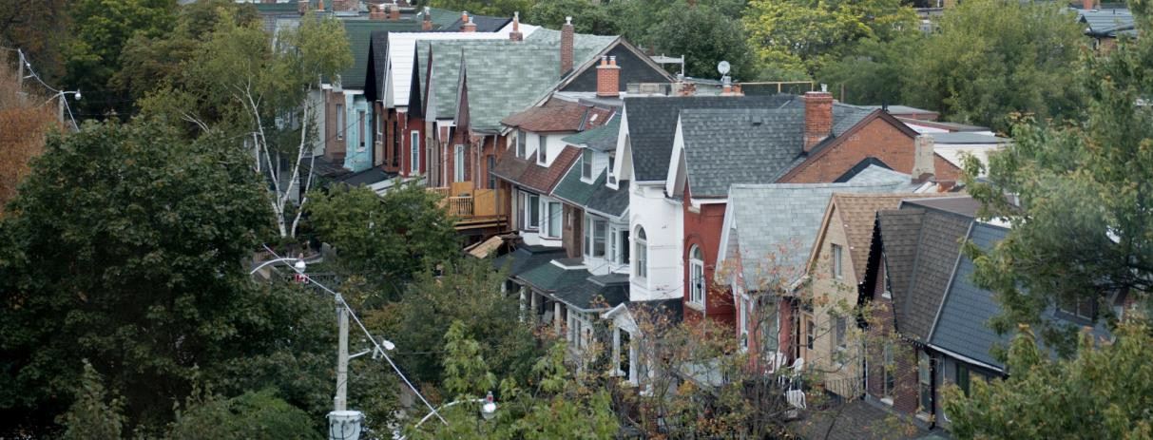

DON’T NEGLECT YOUR
HEALTH.
WE ARE HERE FOR YOU.

When COVID-19 hit our city, Torontonians answered the call to stay home and keep a safe distance from others. So much of our lives have been changed by the pandemic – we are working from home, meeting friends and family virtually and cancelling non-essential appointments. Thank you for doing your part in flattening the curve and saving lives.

But, one thing has not changed: It is still safe to access necessary medical care if and when you need it.

Please do not neglect your health out of fear of catching COVID-19. We have made many changes to be able to care for you in a safe environment.

If you have an emergency, please go to your local Emergency Department immediately. We are taking extraordinary measures to make sure our Emergency Departments are safe for you to receive urgent medical care.

When it is not an emergency, the best place to go for care is your primary care provider (family doctor or nurse practitioner). Your primary care provider has also made a number of changes to the ways they can care for you, like appointments over the phone, or virtual visits. Please call them to make an appointment if you’re concerned about your health.

If you are a caregiver, you may be feeling overwhelmed as services that you have used for supports might have changed during the pandemic. That doesn’t mean that there aren’t resources available to support you. Please contact your primary care provider or community support service provider to learn more about the supports available to you.

These times can be very difficult and it’s okay to not be okay. If you’re feeling anxious or stressed, there are supports available to you online or by phone. Please contact your primary care provider or community support services to learn more about your options.

COVID-19 has changed a lot, but it hasn’t changed our commitment to providing you with the care you need.

If you have any questions or concerns, please call us at [XXX-XXX-XXXX].

